Paddle Palace 2005 Seattle Open

June 11 and 12

Boeing Oxbow Recreation Center

Seattle, Washington

★★ USATT SANCTIONED TWO STAR TOURNAMENT ★★

Sponsors


Boeing Employees Table Tennis Association

Bellevue Table Tennis Club

Prizes: 1st 2nd Semi’s
Open Singles $300 $150 $50
Open Doubles (Per Team) $150 $50 + $50 GC $50 GC
U-2350 $100 $50 $25 GC
U-2150 $50 $25
U-1950 $50 GC $25 GC
U-3800 Doubles (Per Team) $50 + $50 GC $50 GC
40+ Senior Singles $50 $25
All other events Award Award
GC - Paddle Palace Gift Certificate.
Deadline: No entry will be accepted after June 8^{th.} All draws will be completed on June 9th. Entries without payment cannot be guaranteed of participation. Cancellation will only be refunded if notification is given before June 9th.
Eligibility: All members of the USATT, CTTA, and all other ITTF affiliates. Non-member must join the USATT to enter any event, except the Boeing Closed events. Obtaining membership may be done at the time of entering the tournament.
All USATT regulations apply. June 11th will be the date used to determine player’s age.
Equipment: Only USATT approved equipment will be used. Nittaku 40mm 3-Star balls (white and yellow). Play is on hard wood floor.
Event: All events are single elimination, except where noted as round robin (RR) in the schedule. All matches are 11 points best of 5 games, except for the Semis and Final of Open Singles, which will be best of 7 games.
Player may be removed from an event at any time should the Tournament Committee decides that the player is overqualified. Decisions of the Tournament Committee will be final.
The Tournament Committee reserves the right to cancel any event if there are insufficient entries. Fees will be refunded for any canceled events.
Director: Daniel Sie.

Committee: Joe Romanosky, Daniel Sie, Frank Chin.

Control Desk: Frank Chin, Tommy Chung, Jerry Li, Steve Ma, Joe Romanosky, Daniel Sie, and Ed Suen.
Referee: Daniel Sie.
For More Information: Daniel Sie ☎ (425) 401-8622 ✉ dsie@microsoft.com, Frank Chin ☎ (425) 643-5317 ✉ bttc93@yahoo.com.
Directions: (See map) I-5 North or South – Take Exit 158, then follow signs to East Marginal Way. Take a right onto E. Marginal Way S. Turn left at S. 102nd (first stop light). Go over bridge and make a left to Boeing Oxbow Recreation Center parking lot (South end of lot).
Doors will be open at 8:30 AM on both Saturday and Sunday.
Players must register at control desk no later than 30 minutes prior to the starting time for their earliest event.

✔ | Time | Saturday | ✔ | Time | Sunday
❏ | 9:00 | 40+ Senior Singles RR | ❏ | 9:00 | 55+ Seniors Singles RR
❏ | 9:00 | U-18 Singles RR | ❏ | 9:00 | U-1350 Singles
❏ | 9:00 | U-1550 Singles | ❏ | 9:00 | U-3800 Doubles
❏ | 10:00 | U-1950 Singles | ❏ | 10:00 | Open Singles RR
❏ | 11:00 | U-1150 Singles | ❏ | 12:00 | U-950 Singles
❏ | 12:00 | 30+ U-1850 Singles RR | ❏ | 12:30 | U-1750 Singles
❏ | 12:00 | Open Doubles | ❏ | 1:00 | U-2150 Singles
❏ | 1:00 | U-14 Singles RR | ❏ | 1:30 | U-2800 Doubles
❏ | 1:00 | U-2350 Singles | ❏ | 2:00 | 30+ U-1450 RR
❏ | 2:00 | Boeing Closed Doubles | ❏ | 12:00 | Boeing Closed Singles RR
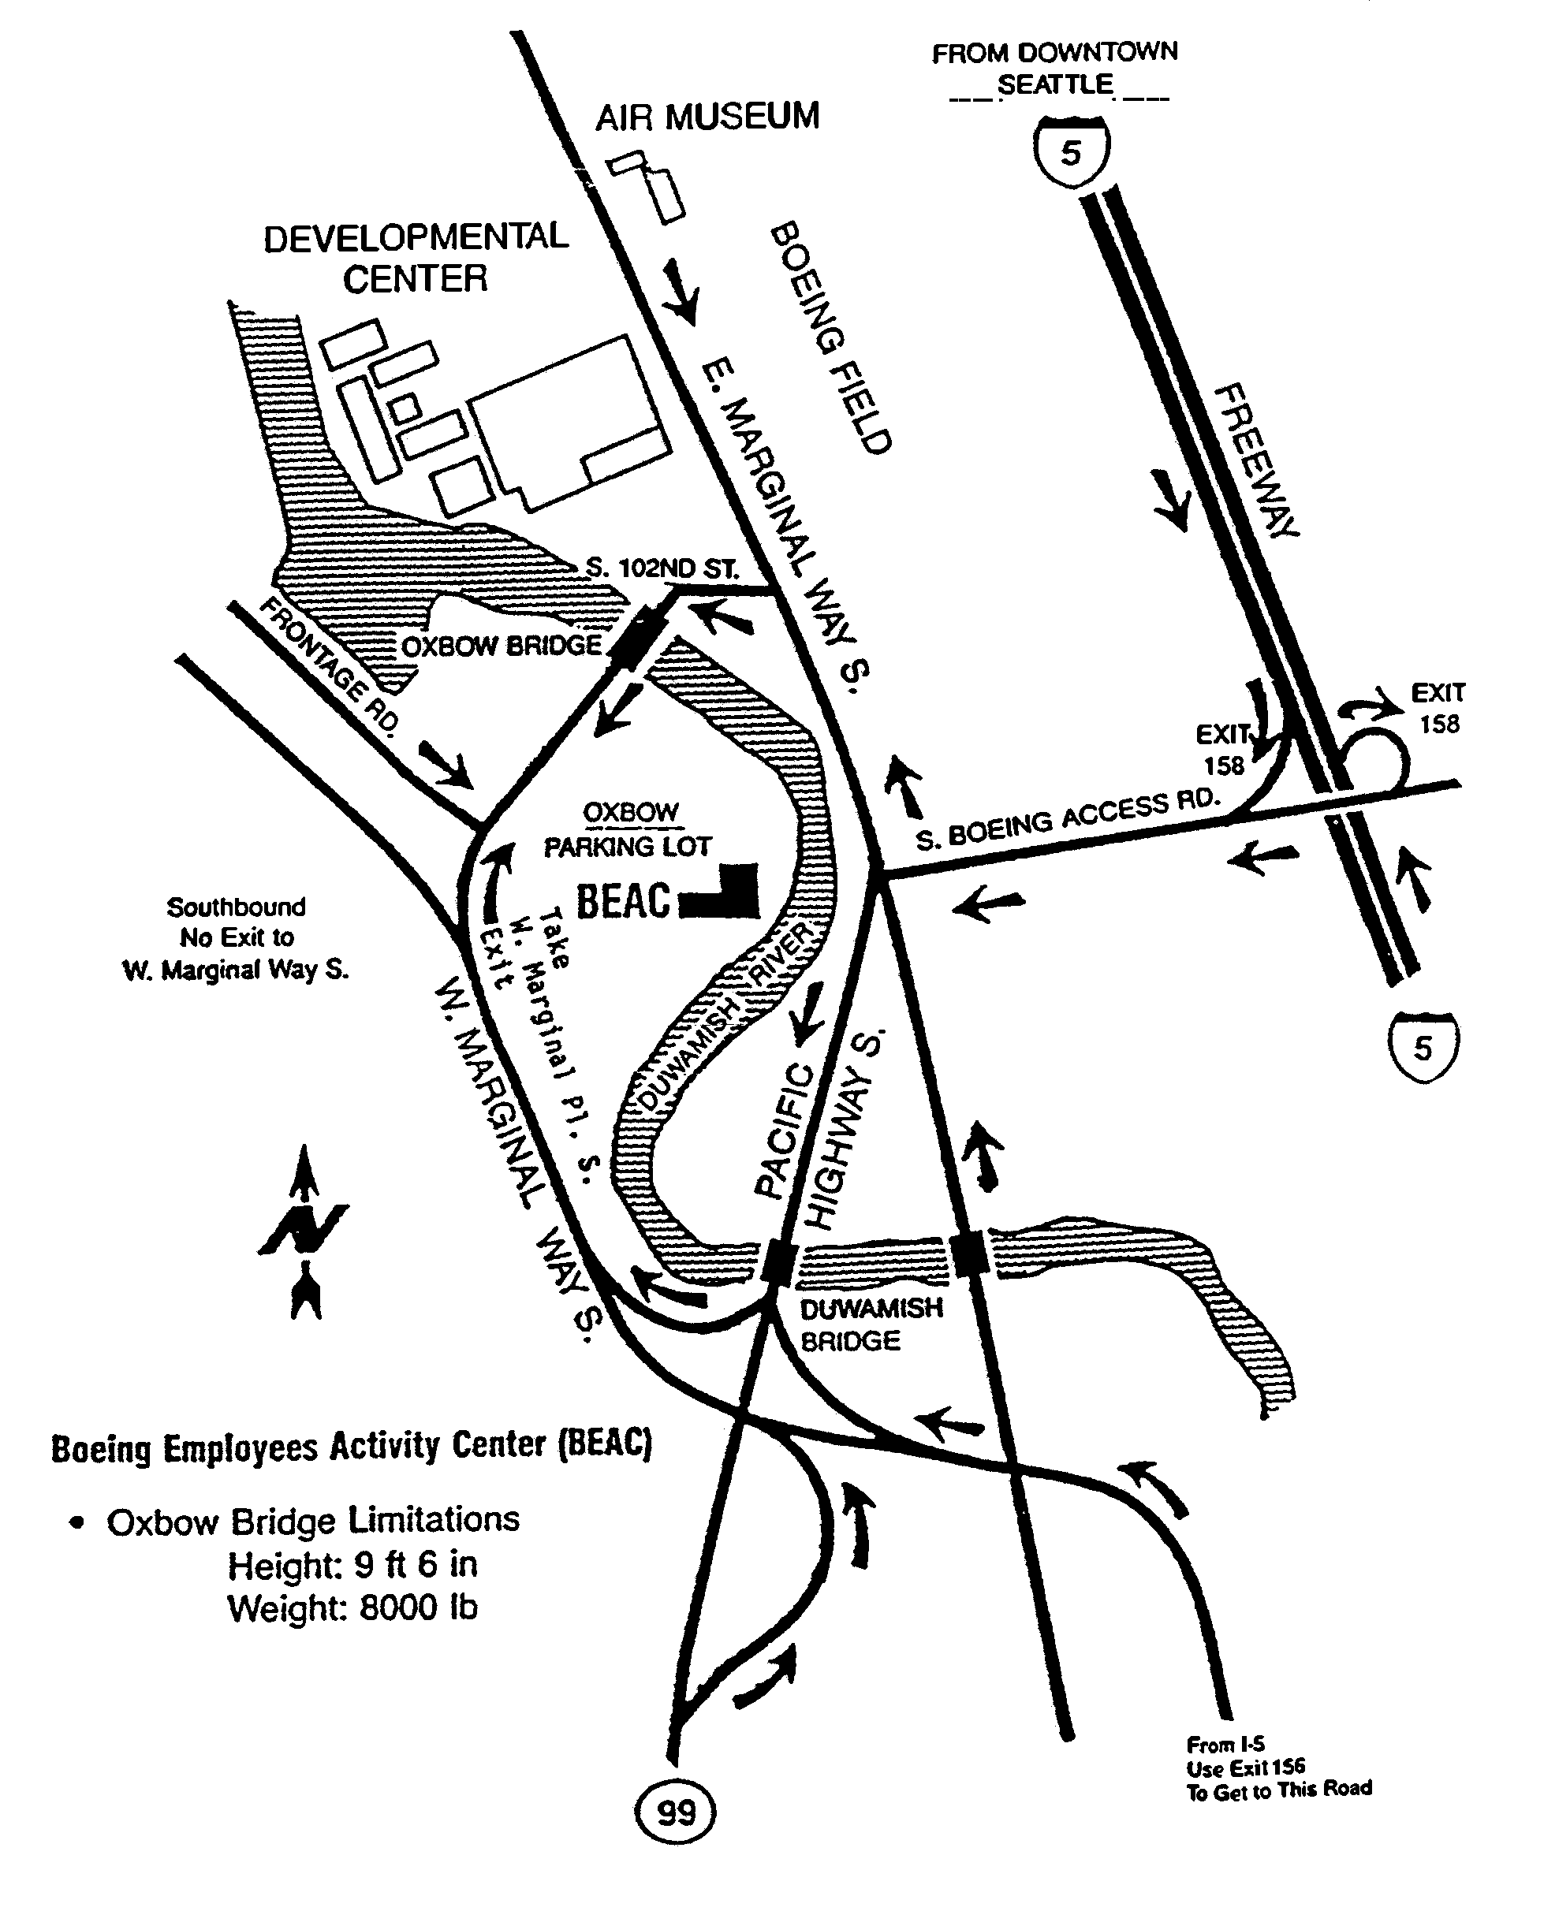
Paddle Palace 2005 Seattle Open Table Tennis Tournament
June 11 and 12

Important: Please fill in all information, as incomplete entry form may not be processed.

Name Email
Street Phone (_____)
City State Zip Birth Date

Boeing Employee? ❏ YES ❏ NO Membership: ❏ USATT ❏ CTTA ❏ OTHER
If YES, Organization Number: Rating: Expiration:

Schedule of Events with Starting Times and Fees
✔ | Time | Saturday | Fee | ✔ | Time | Sunday | Fee
❏ | 9:00 | 40+ Senior Singles RR | $12 | ❏ | 9:00 | 55+ Seniors Singles RR | $10
❏ | 9:00 | U-18 Singles RR | $6 | ❏ | 9:00 | U-1350 Singles | $10
❏ | 9:00 | U-1550 Singles | $10 | ❏ | 9:00 | U-3800 Doubles✜ | $10 Each
❏ | 10:00 | U-1950 Singles | $12 | ❏ | 10:00 | Open Singles RR | $20, $15 if U-2000
❏ | 11:00 | U-1150 Singles | $10 | ❏ | 12:00 | U-950 Singles | $10
❏ | 12:00 | 30+ U-1850 Singles RR | $15 | ❏ | 12:30 | U-1750 Singles | $10
❏ | 12:00 | Open Doubles✜ | $15 Each | ❏ | 1:00 | U-2150 Singles | $12
❏ | 1:00 | U-14 Singles RR | $6 | ❏ | 1:30 | U-2800 Doubles✜ | $10 Each
❏ | 1:00 | U-2350 Singles | $15, $12 if U-2000 | ❏ | 2:00 | 30+ U-1450 Singles RR | $15
❏ | 2:00 | Boeing Closed Doubles✜✪ | $6 Each | ❏ | 12:00 | Boeing Closed  Singles RR✪ | $6
✜ Enter only one doubles event per day.
✪ Only Boeing employees, current or retired, may play in Boeing Closed event.

Total Event Fees $ Double Partners

USATT Membership Fees (From Below)✚ $ Open
Rating Fees (Mandatory)✚ $_________4.00 U-3800
Total Fees Owed (U.S.D) $ U-2800
Boeing

✚ Boeing Closed event participants need not pay any additional fees or membership dues unless entered in other events as well.

Pay by check or money orders made payable to BTTC. Entry without payment will NOT be processed. Send this entry with payment to: | BTTC  C/O Frank Chin  4531 143rd Ave. SE  Bellevue, WA 98006

WAIVER OF LIABILITY: I agree to abide by all rules and hereby release the USATT, the sponsors and all its associates from any loss, damage, or injury that may result from my participation in this tournament.

Signature (Mandatory): Date:
(Parent or guardian must sign for a minor)

USATT Membership: Current USATT or other ITTF affiliate membership is required of all participants, except those playing only in the Boeing Closed events. If you are not a member or wish to renew your membership, please check the appropriate type of subscription and include payment with your entry fees.

❏ Adult 1 Year $40 ❏ Adult 3 Years $100 ❏ Collegiate¹ $20

❏ Junior U-18 1 Year² $20 ❏ Junior U-15 3 years³ $50 ❏ Millennium Life $650

¹ Available only to full-time students of an accredited college or university. Proof of enrollment is required.
² Available only to juniors 17 years old or younger.
³ Available only to juniors 14 years old or younger.

Entry Form  Enclosed | Seattle, WA  Paddle Palace 2005 Seattle Open  Table Tennis Tournament  June 11 and 12

BTTC

C/O Frank Chin
4531 143rd Ave. SE
Bellevue, WA 98006

