Paddle Palace 2002 Seattle Open

June 8 and 9

Boeing Oxbow Recreation Center

Seattle, Washington

★★ USATT SANCTIONED TWO STAR TOURNAMENT ★★

Sponsors


Boeing Employees Table Tennis Association

Bellevue Table Tennis Club

Prizes: 1st 2nd Semi’s Qtr’s
Open Singles $300 $150 $75 $25
Open Doubles (Per Team) $200 $100 $50
Women’s Singles $100 $50
U-2350 $100 $50 $25 GC
U-2150 $50 + $50 GC $25 + $25 GC
U-1950 $50 GC $25 GC
U-3800 Doubles (Per Team) $100 GC $50 GC
40+ Senior Singles $50 GC $25 GC
All other events Award Award
GC - Paddle Palace Gift Certificate.
Deadline: No entry will be accepted after June 5th. All draws will be completed on June 6th. Entries without payment cannot be guaranteed of participation. Cancellation will only be refunded if notification is given before June 6th.
Eligibility: All members of the USATT, CTTA, and all other ITTF affiliates. Non-member must join the USATT to enter any event, except the Boeing Closed events. Obtaining membership may be done at the time of entering the tournament. All USATT regulations apply. June 8th will be the date used to determine player’s age.
Equipment: Only USATT approved equipment will be used. Nittaku 40mm 3-Star balls (white and yellow). Play is on hard wood floor.
Event: All events are single elimination, except where noted as round robin (RR) in the schedule. All matches are 11 points best of 5 games, except for the Semis and Final of Open Singles, which will be best of 7 games.
Player may be removed from an event at any time should the Tournament Committee decides that the player is overqualified. Decisions of the Tournament Committee will be final.
The Tournament Committee reserves the right to cancel any event if there are insufficient entries. Fees will be refunded for any canceled events.

Tournament Directors: Joe Romanosky, Daniel Sie.

Control Desk: Frank Chin, Tommy Chung, Steve Ma, Joe Romanosky, Daniel Sie, and Ed Suen.
Referee: Daniel Sie.
For More Information: Daniel Sie at ☎ (425) 401-8622 ✉ dsie@microsoft.com
Frank Chin at ☎ (425) 643-5317 ✉ FRANKCH@Attachmate.com
Directions: (See map) I-5 North or South – Take Exit 158, then follow signs to East Marginal Way. Take a right onto E. Marginal Way S. Turn left at S. 102nd (first stop light). Go over bridge and make a left to Boeing Oxbow Recreation Center parking lot (South end of lot).
Doors will be open at 8:30 AM on both Saturday and Sunday.
Players must register at control desk no later than 30 minutes prior to the starting time for their earliest event.

✔ | Time | Saturday, June 8 | ✔ | Time | Sunday, June 9
❏ | 9:00 | 40+ Senior Singles | ❏ | 9:00 | 55+ Seniors Singles
❏ | 9:00 | Youth U-18 Singles | ❏ | 9:00 | U-1350 Singles
❏ | 9:00 | U-1550 Singles | ❏ | 9:00 | U-3800 Doubles
❏ | 10:00 | U-1950 Singles | ❏ | 10:00 | Open Singles RR
❏ | 11:00 | Women’s Singles RR | ❏ | 12:00 | U-950 Singles
❏ | 12:00 | U-1150 Singles | ❏ | 12:30 | U-1750 Singles
❏ | 12:00 | Open Doubles | ❏ | 1:00 | U-2150 Singles
❏ | 1:00 | Youth U-12 Singles | ❏ | 1:30 | U-2800 Doubles
❏ | 1:00 | U-2350 Singles | ❏ | 2:00 | Hard Bat Singles
❏ | 2:00 | Boeing Closed Doubles | ❏ | 12:00 | Boeing Closed Singles RR
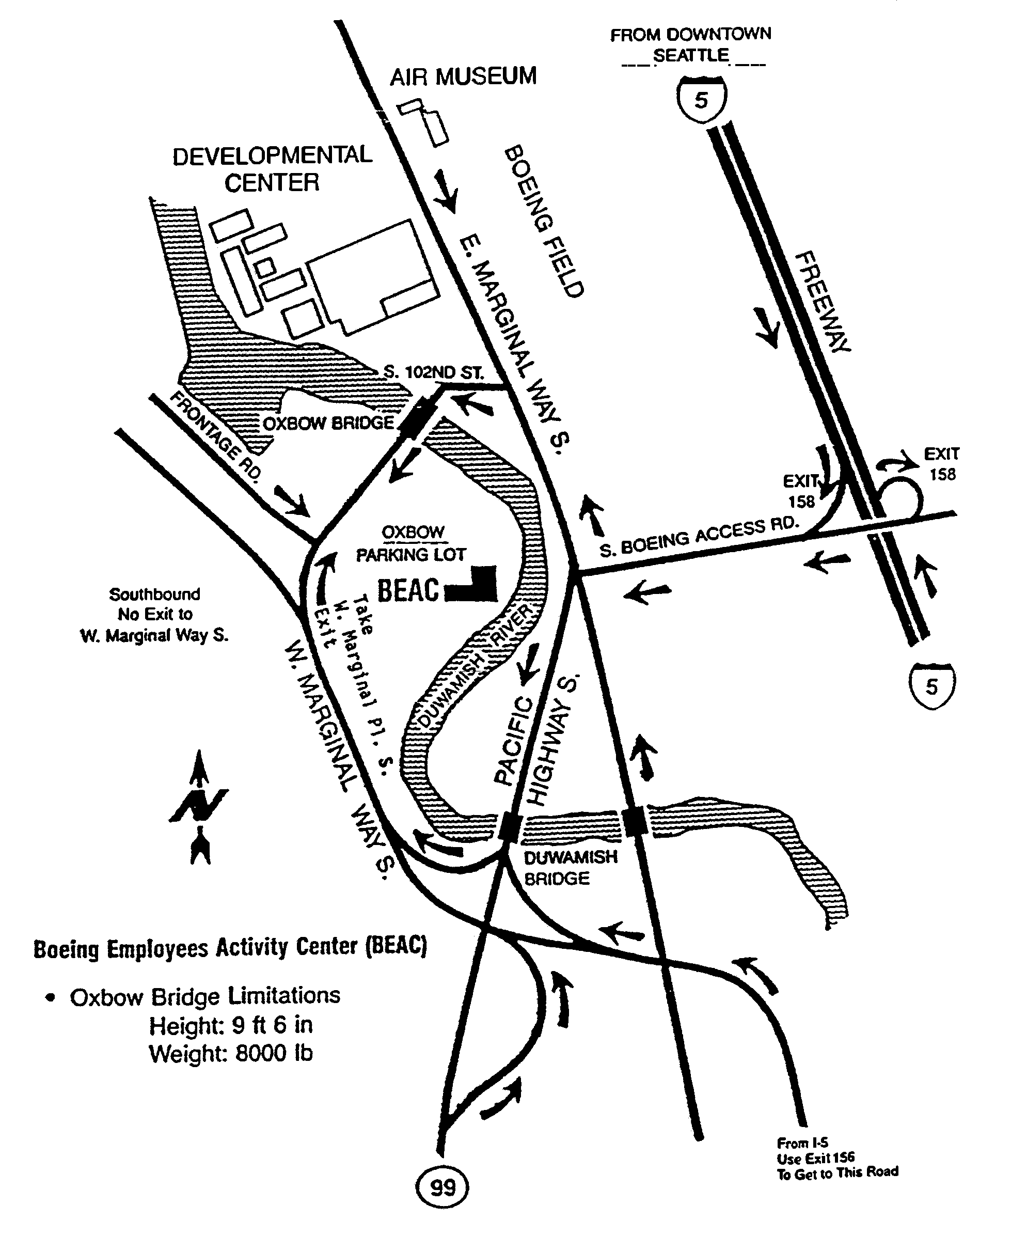
Paddle Palace 2002 Seattle Open Table Tennis Tournament
June 8 and 9

Name Rating
Street Birth Date

City State Zip Phone (_____)

Boeing Employee? ❏ YES ❏ NO Membership: ❏ USATT ❏ CTTA ❏ OTHER
If YES, Organization Number: Expiration:

Schedule of Events with Starting Times and Fees

✔ | Time | Saturday | Fee | ✔ | Time | Sunday | Fee
❏ | 9:00 | 40+ Senior Singles | $10 | ❏ | 9:00 | 55+ Seniors Singles | $8
❏ | 9:00 | Youth U-18 Singles | $6 | ❏ | 9:00 | U-1350 Singles | $8
❏ | 9:00 | U-1550 Singles | $8 | ❏ | 9:00 | U-3800 Doubles✜ | $10 Each
❏ | 10:00 | U-1950 Singles | $10 | ❏ | 10:00 | Open Singles RR | $20, $15 if U-2000
❏ | 11:00 | Women’s Singles RR | $15, $12 if U-2000 | ❏ | 12:00 | U-950 Singles | $8
❏ | 12:00 | U-1150 Singles | $8 | ❏ | 12:30 | U-1750 Singles | $8
❏ | 12:00 | Open Doubles✜ | $12 Each | ❏ | 1:00 | U-2150 Singles | $12
❏ | 1:00 | Youth U-12 Singles | $6 | ❏ | 1:30 | U-2800 Doubles✜ | $8 Each
❏ | 1:00 | U-2350 Singles | $15, $12 if U-2000 | ❏ | 2:00 | Hard Bat Singles | $8
❏ | 2:00 | Boeing Closed Doubles✜✪ | $3 Each | ❏ | 12:00 | Boeing Closed  Singles RR✪ | $6
✜ Enter only one doubles event per day.
✪ Only Boeing employees, current or retired, may play in Boeing Closed event.

Total Event Fees $ Double Partners

USATT Membership Fees (From Below)✚ $ Open
Rating Fees (Mandatory)✚ $ 3.00 U-3800
Total Fees Owed (U.S.D) $ U-2800
Boeing

✚ Boeing Closed event participants need not pay any additional fees or membership dues unless entered in other events as well.

Pay by check or money orders made payable to BTTC, and send this entry with payment to:

All telephone entries to Frank Chin: | BTTC c/o Frank Chin
Home: (425) 643-5317 | 4531 143rd Ave SE
Email: FRANKCH@Attachmate.com | Bellevue, WA 98006

WAIVER OF LIABILITY: I agree to abide by all rules and hereby release the USATT, the sponsors and all its associates from any loss, damage, or injury that may result from my participation in this tournament.

Signature (Mandatory): Date:
(Parent or guardian must sign for a minor)

USATT Membership: Current USATT or other ITTF affiliate membership is required of all participants, except those playing only in the Boeing Closed events. If you are not a member or wish to renew your membership, please check the appropriate type of subscription and include payment with your entry fees. The One-Time pass provides USATT membership for this tournament only, and is not available to past USATT member.

❏ Adult 1 Year $30 ❏ Junior U-15 3 Years $45 ❏ Collegiate $20

❏ Adult 3 Years $75 ❏ Household 1 Year $50 ❏ Millennium Life $500

❏Junior U-18 1 Year $20 ❏ Household 3 Years $125 ❏ One-Time Pass $7

Entry Form  Enclosed | Seattle, WA  Paddle Palace 2002 Seattle Open  Table Tennis Tournament  June 8 and 9

BTTC c/o Daniel Sie
15902 SE 48th Drive
Bellevue, WA 98006

